Source Control on Visual Studio Code and Github

I use Github Desktop for windows.

Select your CSoftDevBranch, and then fetch origin.

On linux, use: git-pull - Fetch from and integrate with local branch

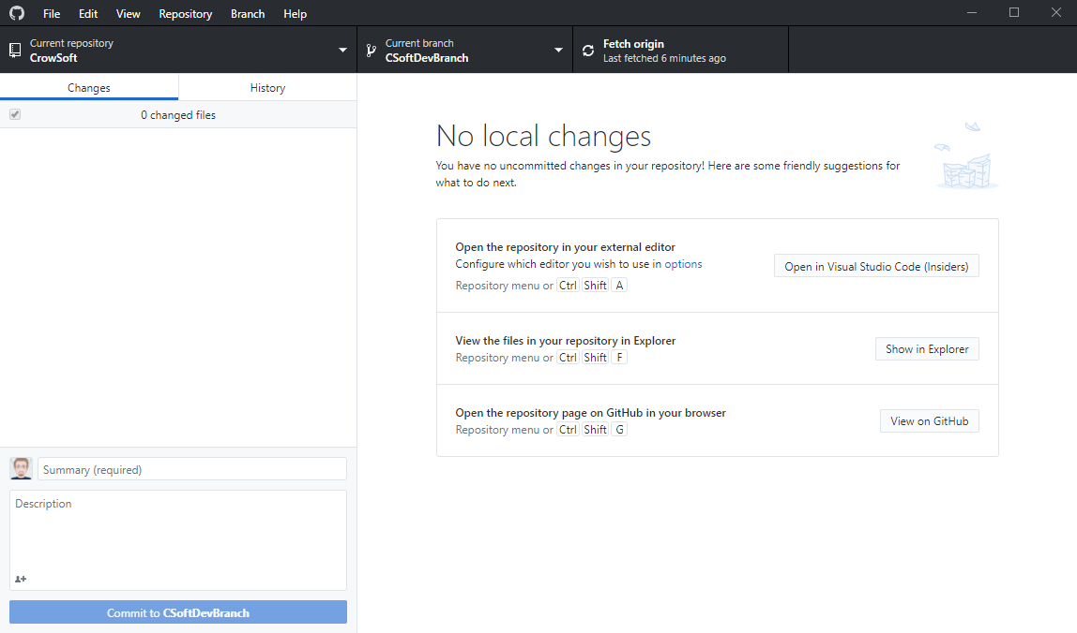

Open Visual Studio Code. Go to File, Open folder.

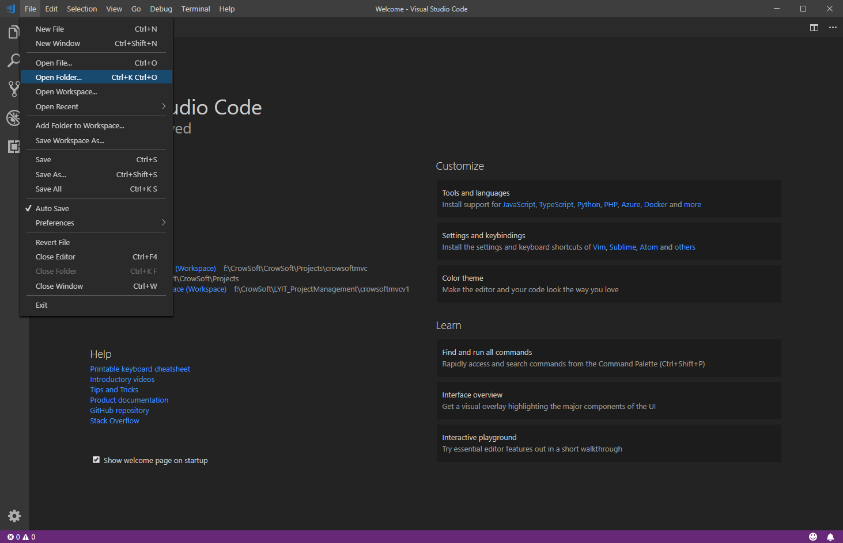

Select the folder on your local drive. **NOTE:** If you see the **CrowSoftMVCWorkSpace.code-workspace** file, then go back, and open the workspace file.

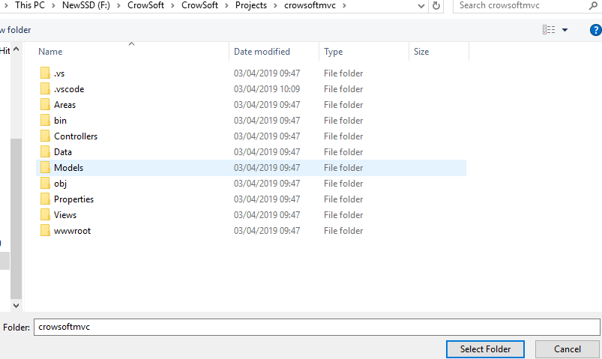

Note  on bottom left of the IDE. This will automatically link to your Github branch if you select the local git folder.

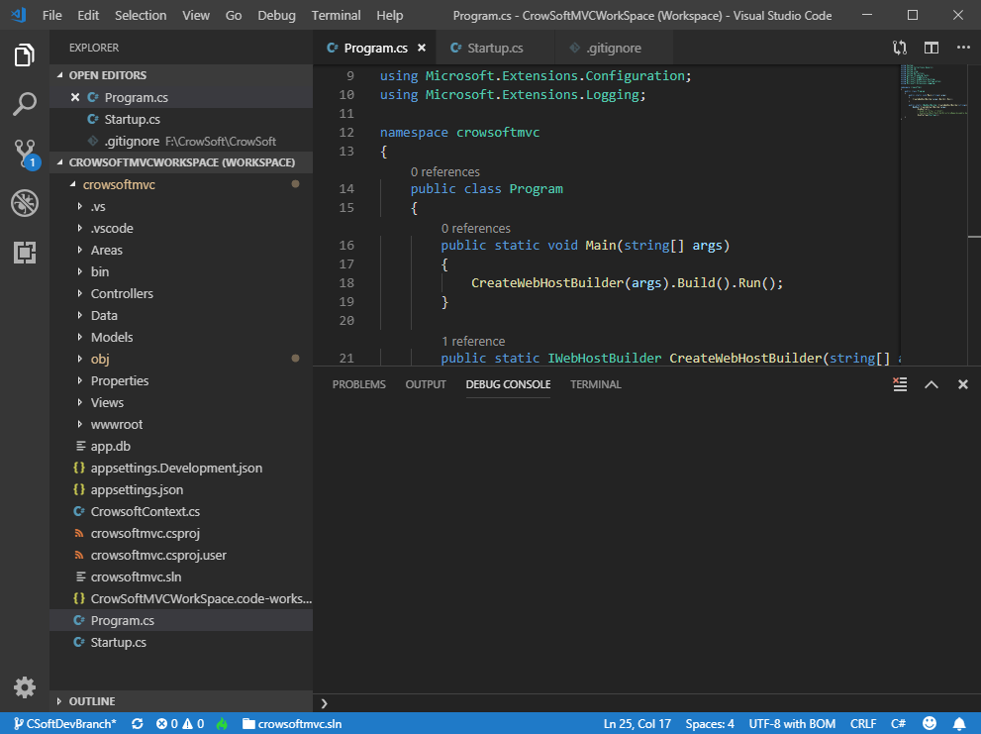

Below is where you can find Source Control.

File Explorer

Search

**Source Control**

Debug

Extensions (To add new extensions)

Let’s debug and run the app. Click on the Debug Icon, then click 

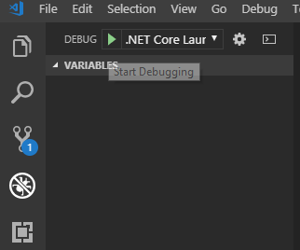

This should open your default browser and run the web application as shown below.

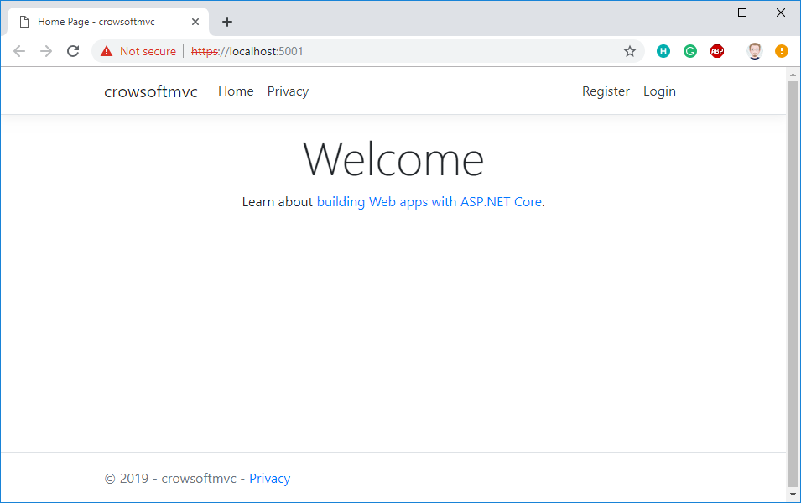

Let’s make a change to the code and check it in. Go to Views/Home/Index.cshtml

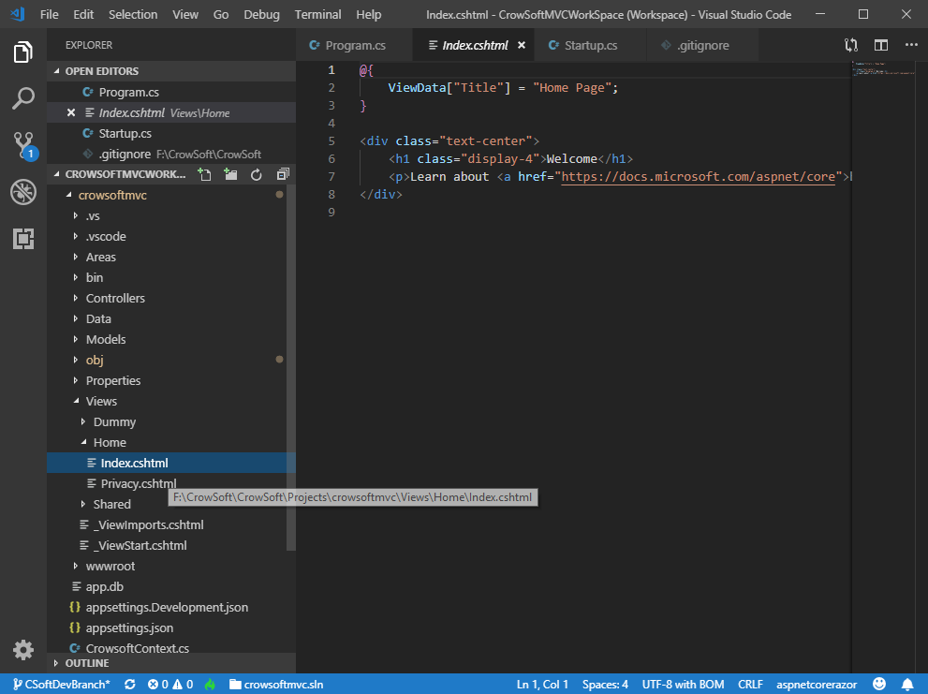

Change the display-4 message to: **Welcome to CrowSoft Engineering**

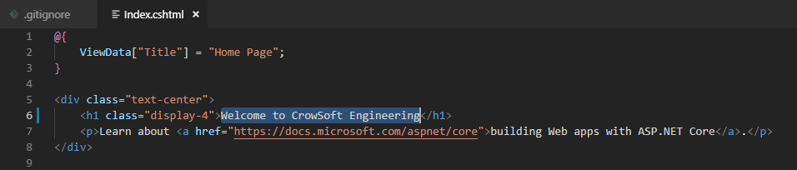

Click File / Save

Then Debug and click  again. You can see then change on the web app below.

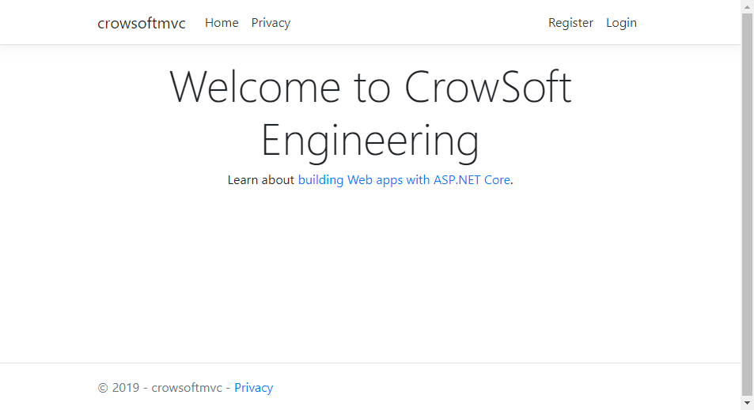

Now let’s check in our changes.

Click on Source Control button. You will see a few CHANGES on the list.

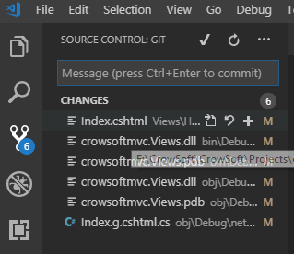

Any dll’s and pdb files, must be ignored and not checked in. You can right click on those, and click Add File to .gitignore.

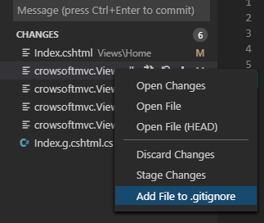

Enter your message below field, and click the commit button or press Ctrl-Enter.

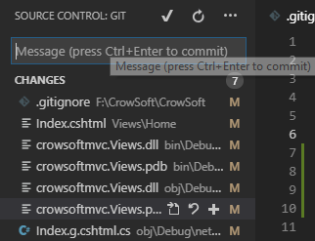

The following screen will appear. Click Yes. **NOTE:** This will only commit code locally. You still need to Push it to Github.

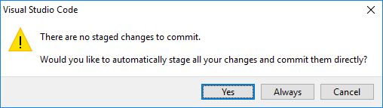

To push changes to Github, open Github Desktop, then Click Push origin or   
for Linux or command line users: ***git push origin CSoftDevBranch***

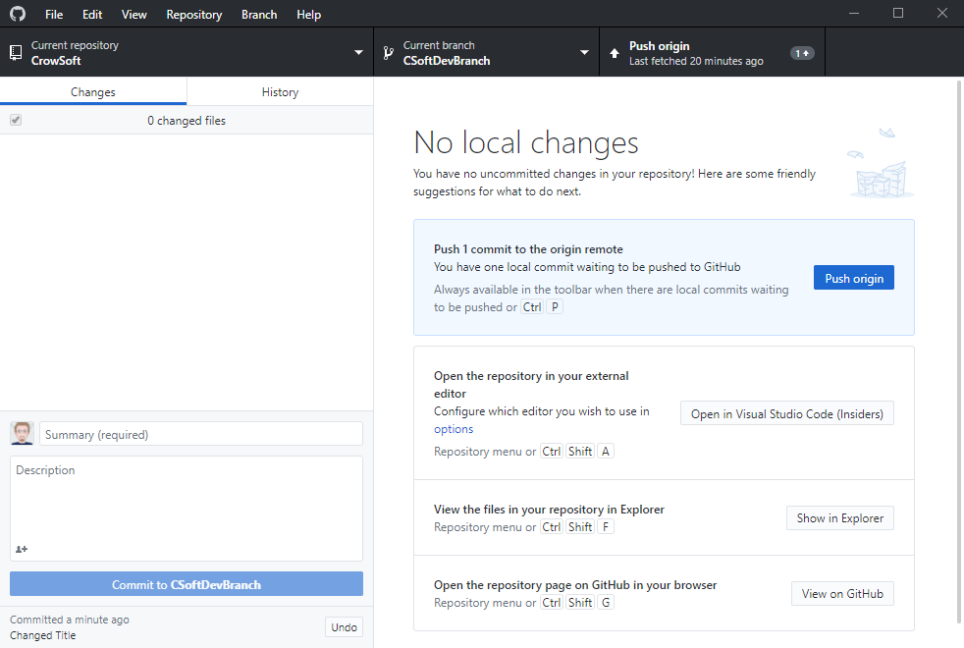

Go to Github.com, then open file in this location: ***CrowSoft/Projects/crowsoftmvc/Views/Home/Index.cshtml***

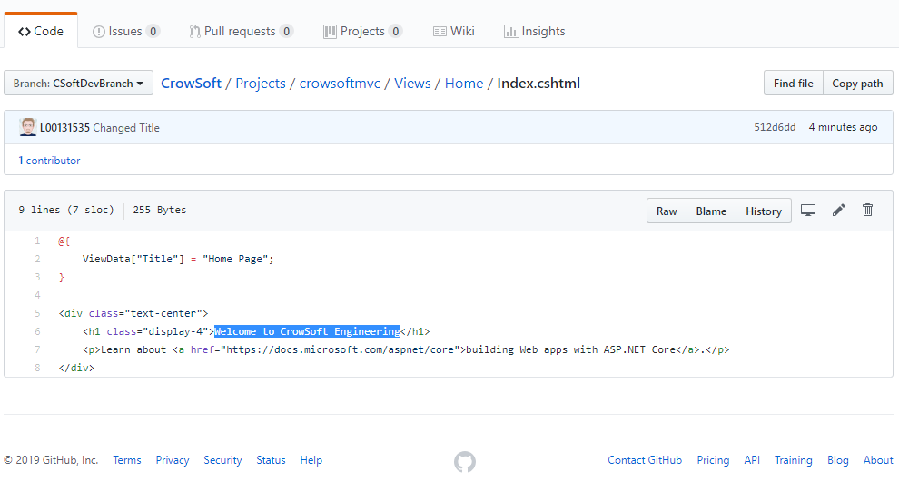

Make sure the change is showing as seen above.

**Bobs your uncle! ☺ Finish!**